1.Write  
a R program to get the unique elements of a given string and unique numbers of  
vector.

Output:

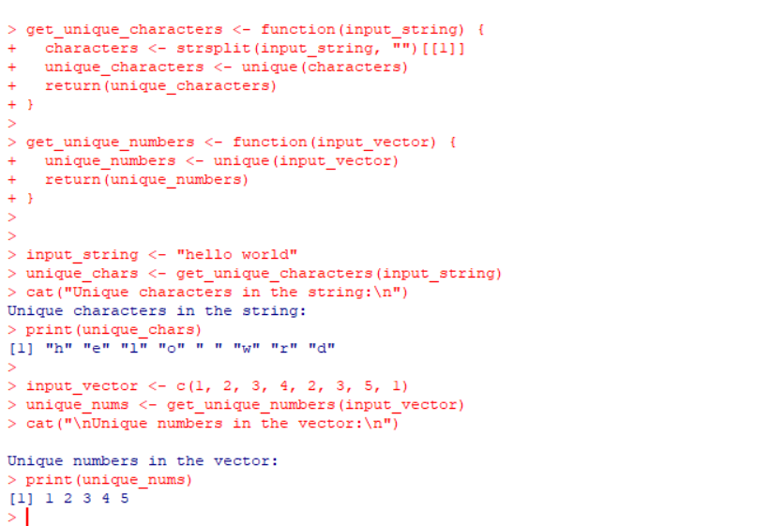

2.Write  
a R program to create three vectors a,b,c with 3 integers. Combine the three  
vectors to become a 3×3 matrix where each column represents a vector. Print the  
content of the matrix.

Output:

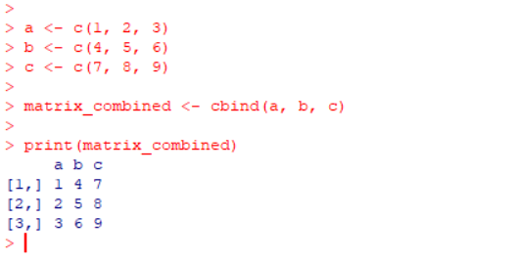

3.Write  
a R program to create a list of random numbers in normal distribution and count  
occurrences of each value.

Output:

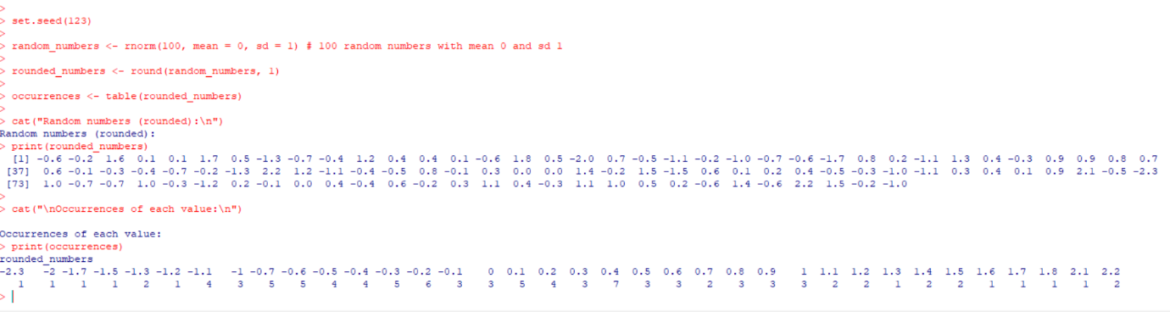

4.Write a R program to create three vectors numeric data, character data and logical  
data. Display the content of the vectors and their type.

Output:

